**Setting up Node.js and NPM**

***Note: Make sure you have installed Git on your machine before you install Node.js. Please complete the previous Git installation exercise before proceeding with this exercise.***

#### **Objectives and Outcomes**

In this exercise, you will learn to set up the Node.js environment, a popular Javascript based server framework, and node package manager (NPM) on your machine. To learn more about NodeJS, you can visit [https://nodejs.org](https://nodejs.org/). For this course, you just need to install Node.js on your machine and make use of it for running some front-end tools. You will learn more about the server-side support using Node.js in a subsequent course. At the end of this exercise, you will be able to:

* Complete the set up of Node.js and NPM on your machine
* Verify that the installation was successful and your machine is ready for using Node.js and NPM.

#### **Installing Node**

* To install Node on your machine, go to [https://nodejs.org](https://nodejs.org/) and click on the Download button. Depending on your computer's platform (Windows, MacOS or Linux), the appropriate installation package is downloaded.
* As an example, on a Mac, you will see the following web page. Click on the Download button. Follow along the instructions to install Node on your machine. (Note: Now Node gives you the option of installing a mature and dependable LTS version and a more newer stable version. You should to install the LTS version. I will use this version in the course.)

**Note: On Windows machines, you may need to configure your PATH environmental variable in case you forgot to turn on the add to PATH during the installation steps.**

#### **Verifying the Node Installation**

* Open a terminal window on your machine. If you are using a Windows machine, open a cmd window or PowerShell window with **admin** privileges.
* To ensure that your NodeJS setup is working correctly, type the following at the command prompt to check for the version of **Node** and **NPM**

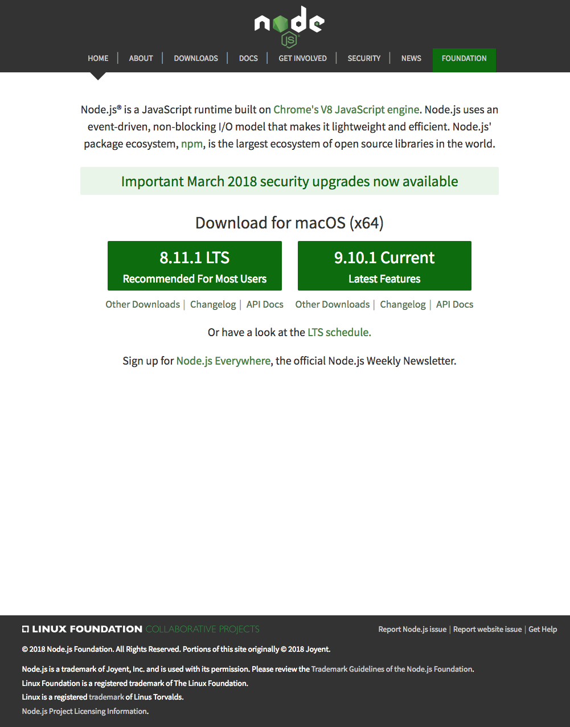

node -v

npm -v

#### **Conclusions**

At the end of this exercise, your machine is now ready with the Node installed for further development. We will examine web development tools next.

**Basics of Node.js and NPM**

#### **Objectives and Outcomes**

In this exercise you will learn the basics of Node and NPM. At the end of this exercise, you will be able to:

* Set up package.json file in the project folder for configuring your Node and NPM for this project
* Install a NPM module and make use of it within your project

#### **Initializing package.json**

* At the command prompt in your **git-test** folder, type

npm init

* Follow along the prompts and answer the questions as follows: accept the default values for most of the entries, except set the entry point to index.html
* This should create a package.json file in your **git-test** folder.

#### **Installing an NPM Module**

* Install an NPM module, lite-server, that allows you to run a Node.js based development web server and serve up your project files. To do this, type the following at the prompt:

npm install lite-server --save-dev

* You can check out more documentation on lite-server [here](https://github.com/johnpapa/lite-server).
* Next, open package.json in your editor and modify it as shown below. Note the addition of two lines, line 7 and line 9.
* {
* "name": "git-test",
* "version": "1.0.0",
* "description": "This is the Git and Node basic learning project",
* "main": "index.html",
* "scripts": {
* "start": "npm run lite",
* "test": "echo \"Error: no test specified\" && exit 1",
* "lite": "lite-server"
* },
* "repository": {
* "type": "git",
* "url": "git+https://jogesh_k_muppala@bitbucket.org/jogesh_k_muppala/git-test.git"
* },
* "author": "",
* "license": "ISC",
* "homepage": "https://bitbucket.org/jogesh_k_muppala/git-test#readme",
* "devDependencies": {
* "lite-server": "^2.2.2"
* }
* }
* Next, start the development server by typing the following at the prompt:

npm start

* This should open your index.html page in your default browser.
* If you now open the index.html page in an editor and make changes and save, the browser should immediately refresh to reflect the changes.

#### **Setting up .gitignore**

* Next, create a file in your project directory named .gitignore (**Note**: the name starts with a period)Then, add the following to the .gitignore file

node_modules

* Then do a git commit and push the changes to the online repository. You will note that the node_modules folder will not be added to the commit, and will not be uploaded to the repository.

#### **Conclusions**

In this exercise you learnt to set up package.json, install a npm package and start a development server.